UTHA Soccer specials
Directions: Choose the package that you would like to purchase, write out the check to McCormick Photography and send it in no later than Thursday March 5.

Picture Packages
Package A | Package B | Package C
  One | 8×10 | COST
  Two | 5×7 | COST
  three | 4×6 | COST
  six | wallets | $25
  Two | 8×10 | COST
  three | 5×7 | COST
  five | 4×6 | COST
  eight | wallets | $40
  three | 8×10 | COST
  six | 5×7 | COST
  eight | 4×6 | COST
  twelve | wallets | $50

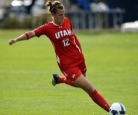

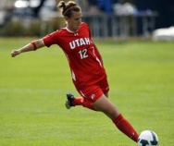




d


d




Order Form
Name: Click here to enter text.
Package choice: Click here to enter text.
Address: Click here to enter text.
Phone number: Click here to enter text.
Payment Method: check ☐ credit card ☐ Cash ☐

